Thursday 6th October 2021

Network Topology

Local Area Networks (LANs)

Advantages:

* Enables digital communication between devices.
* Able to share peripheral devices eg printers/scanners.
* Allows for central management.

Disadvantages:

* Requires expertise to install.
* Many security issues that allow unauthorised access to data.

Methods of securing networks:

* Strong passwords with a range of character types
* Encryption over wireless connections
* User access rights – Eg standard users cannot install programs

Network Components – Hub:

A hub is a device which connects components together. All connected nodes (devices) act as a single segment. However, it is not intelligent – data packets are transmitted across the entire network.

Network Components – Switch:

A switch also connects components together like a hub. However, it is intelligent, and can connect to different segments on the network. This reduces network traffic, as packets are only being sent to where they need to go.

Network Components – Router

If the LAN is connected to the internet, it requires a router. Routers manage the data packets, enabling them to be sent over the internet.

Network Types – Peer to Peer

In a peer to peer network, all connected devices have the same status – no one device is control. Data transfer is often slower, due to data collisions and shared processer power. This network type is only really suitable for small or low traffic networks. This is a common type for home networks.

Network Types – Client to Sever

In a client server network, at least one computer is designated as a server, this is normally a high end device. The server offers software and data to client devices. Clients must sign into this network, so that they can have the appropriate permissions.

Network Topologies – Bus

In a bus network, each device is connected to the main shared cable. It is very cheap due to it requiring very little cabling. However, because data travels along the shared cable, data collisions can lead to reduced speed and if the main cable breaks the whole network will suffer.

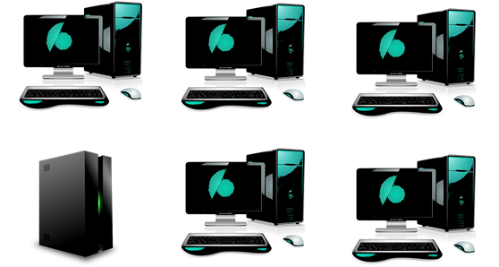

Network Topologies – Mesh Networks

This is a fully connected network, every node (device) is connected to each other. This means that if one cable breaks or is very slow, there is other routes for the data. However, it is very expensive due to the large amounts of cabling required.

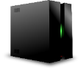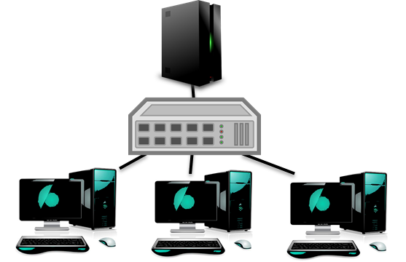

Network Topologies - Star

In a star network, every device is connected to a hub or switch, which means that data does not share one cable. Because of this, there are less data collisions, and a faster network. However, this network type is expensive because it requires lots of cabling

